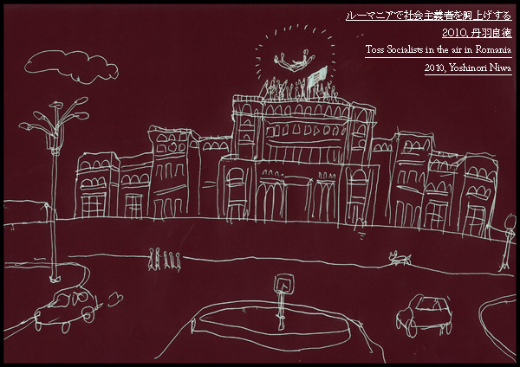

“Intervention Art Project “Toss socialists in the air in Romania” Yoshinori Niwa, 2010

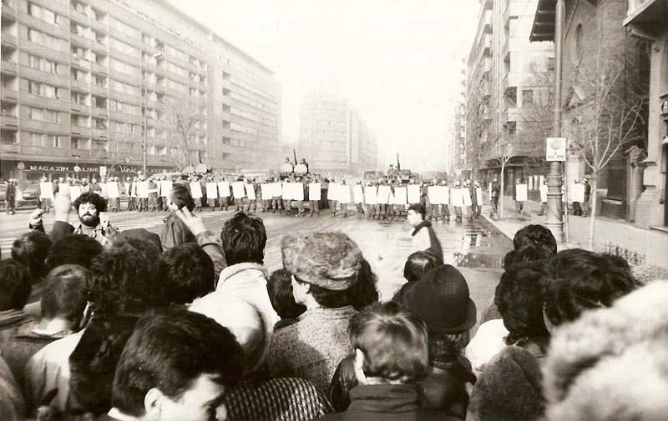
Tanks and Miliţia on the Magheru Boulevard in Bucharest, during the Romanian Revolution of 1989

Project Outline
In Bucharest, the capital of the East European country of Romania, at the Contemporary Art Centre PAVILION UNICREDIT I will realize the participatory project “Tossing Socialists in the air”. Taking Bucharest 20 years after revolution as its stage, this project will entail tossing successors to the political members of the former communist party into the air upon the roof of the former communist head quarters (now the site of the Upper House). No matter whether they have had direct experience of the revolution or not, general people of many different generations will be called upon to join this project, in addition providing detailed interviews for the purposes of research and documentation. Questioning their aversion to socialism in a record of their personal feelings, their sorrows and their memories, a step will be taken inside historical fact. The words and expressions of the participants, collated through video and other documentation, will be exhibited alongside the performance itself, the many layers of personal feeling reflecting the multiple layers of Romania’s history, in a paradoxical questioning of contemporary capitalism.

But this project’s essential meaning is not only linked to a distant country. It can also paradoxically be overlaid upon Japan’s own history. In Japanese history we have never experienced a socialist state, and have never undergone popular revolution. But these incidents have been repeated in countries all over the world and continue even today. As an artist I am not appealing to socialism, throughout the world tragedy of political conflict is kept within the memories of all. In this project I see my role as an artist to link the unseen condition of today’s society with the history of the past, and through the use of humour to open a hole in the reality of our social fabric to allow for a reconsideration of contemporary society, and embolden us in our lives.

What is social interventionist action?
In this project it is aimed to create a point of contact with a new kind of society through the “action” of contemporary art. In relation to a specific community or society, taking on an action which is filled with humour, through an absurd nonsensical idea, I believe we can gain a new perspective on reality in which we live. This is a form of art enters into the fabric of social relations, directly engaging general citizens and receiving their response. In this case taking Romania, 20 years after revolution as our stage, we shall toss the socialists who have been buried by history.

Tossing in the air (JP. douage)
This is an action intended for someone who has made a great achievement, or who deserves a celebration, and is undertaken by group of people who throw the individual into the air several times. In this project “Tossing Socialists in the air in Romania” a self contradictory action of celebrating communism, which has largely been negatively associated through history of communism, is undertaken to summon up historical memories and feelings kept inside individual. It may be thought by Japanese that tossing in the air (douage) is a traditional custom of Japan but in fact in recent years it has become common amongst European football teams. And records from 1927 suggest that the first woman pilot to fly across Atlantic also received such celebration when she arrived in Paris.

Romanian Revolution of 1989 from Wikipedia
The Romanian Revolution of 1989 was a week-long series of increasingly violent riots and fighting in late December 1989 that overthrew the government of the totalitarian president Nicolae Ceauşescu. After a trial, Ceauşescu and his wife Elena were executed. Romania was the only Eastern Bloc country to overthrow its government forcefully or to execute its leaders.

Project ：Intervention Art Project “Toss socialists in the air in Romania
Participate program：Utopia of Exotic, group show
Curator：Andrei Craciun (b. 1988)
Residency：30th Nov – 21th Dec, 2010
Artist : Yoshinori Niwa
Grant：The Asahi Shinbun Foundation (apply)
Co-organize：PAVILION and BUCHAREST BIENNALE
Venue：PAVILION UNICREDIT
Coordinator：Razvan Ion, Eugen Radescu and Andrei Craciun
Address：Pavilion Unicredit (Sos. Nicolae Titulescu nr. 1 (Piata Victoriei), Bucuresti)
URL : http://www.pavilionunicredit.org/

Production Schedule (Plan)
30th November 2010 Leave for Romania
1st-8th December Undertake research and meet with local staff
9th-10th December Realization of project
11th-20th December Produce documentation
21st December Return to Japan
2011 Produce documentation catalogue

Artist
Niwa Yoshinori
Born 1982, Aichi prefecture, Japan. Graduated Tama Art University 2005. Always on the move, Niwa has realized a wide number of community based projects and social interventionist performances throughout Japan and internationally. His major works include “Yankee Chicken Farm”, trying to explain the Iraq war to a chicken at the height of the bird flu outbreak, “Transform puddle A to puddle B”, moving water from a puddle in East Berlin to West Berlin. Exhibitions include “Complex Circuit － The Poetics of Activism” atαM gallery and “No Solution, but Brawl” Ai Kowada Gallery. He has also participated in the following artist in residence programs 2005 VENT Residency Programme (Oxford, UK), 2010 HIAP-Helsinki International Artist-in-residency Programme (Helsinki, Finland)
http://www.niwa-staff.org/
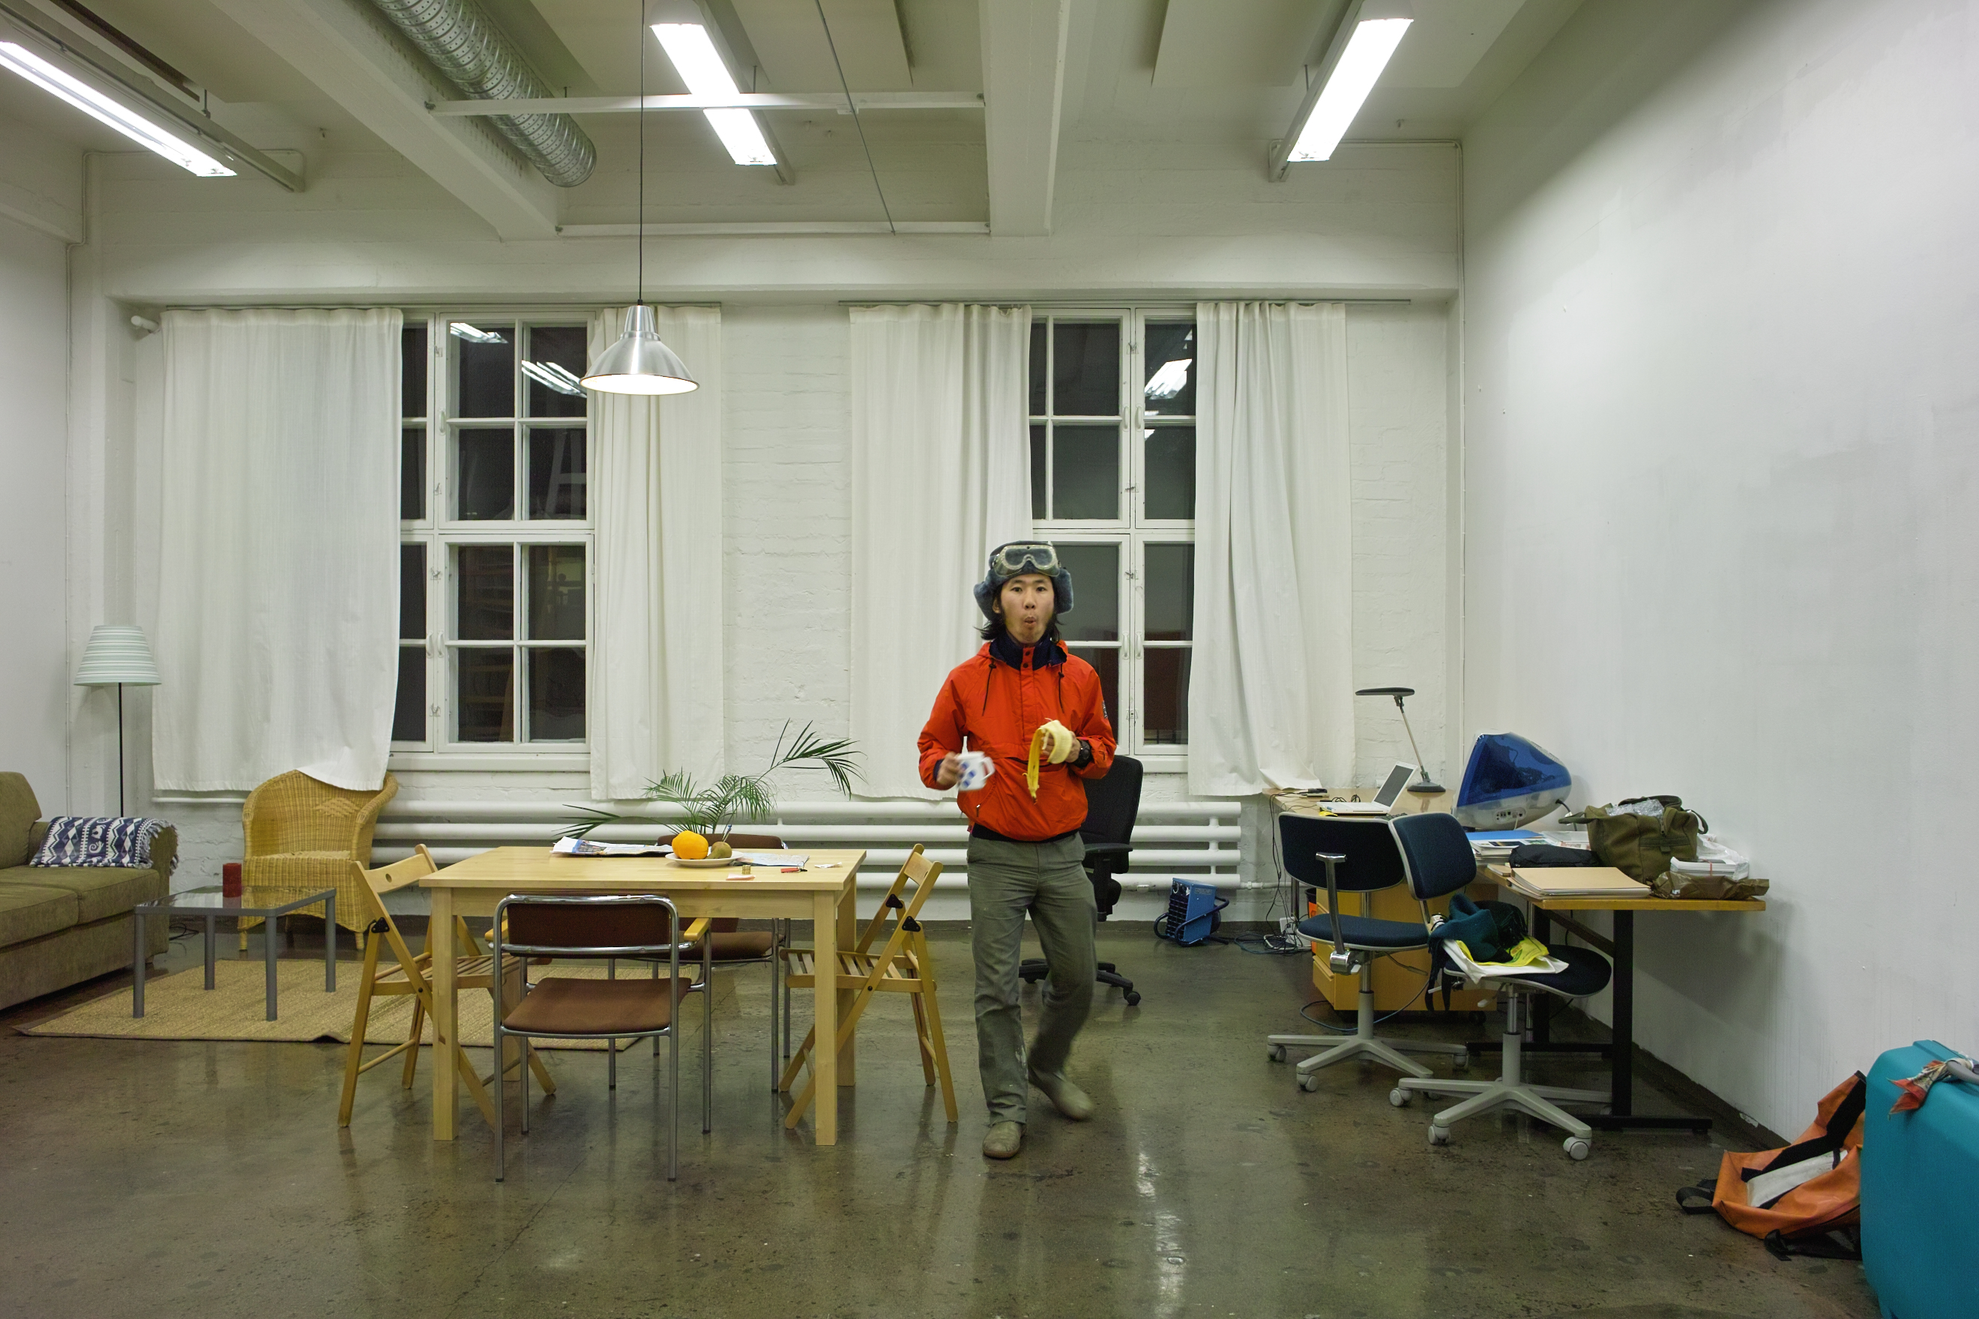
Yoshinori Niwa at the studio, Helsinki 2010

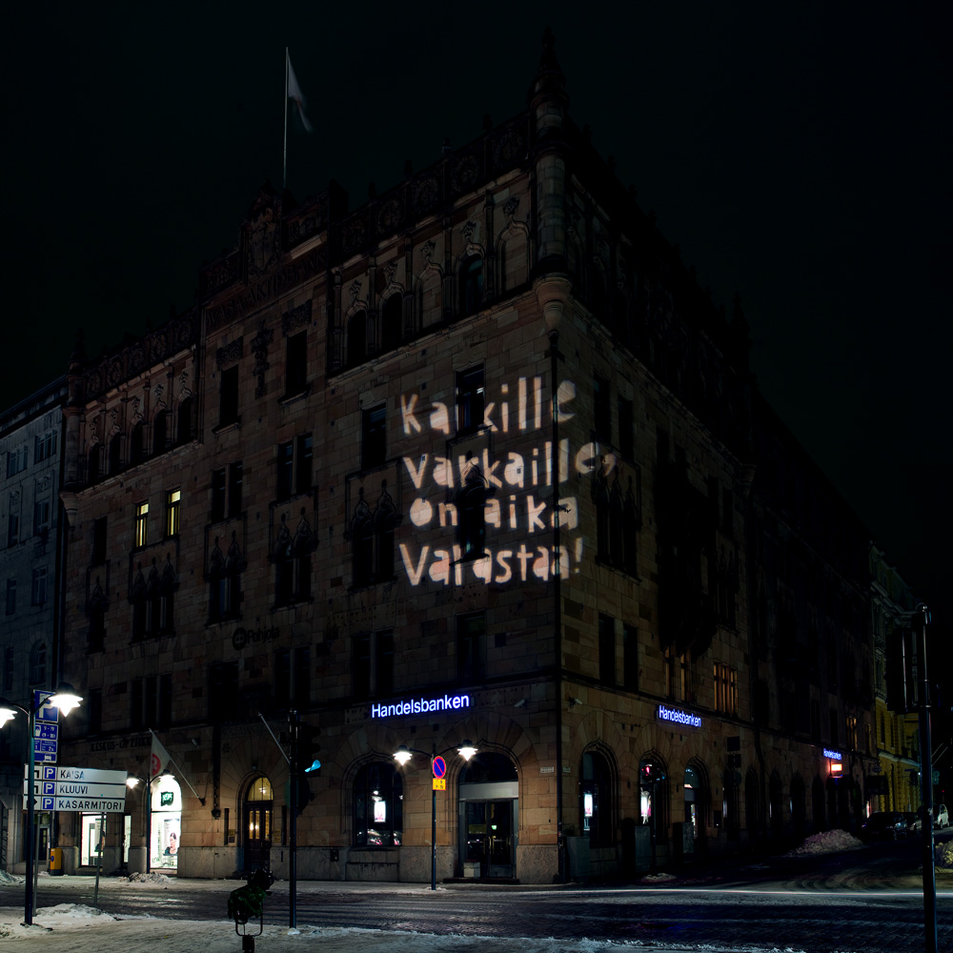

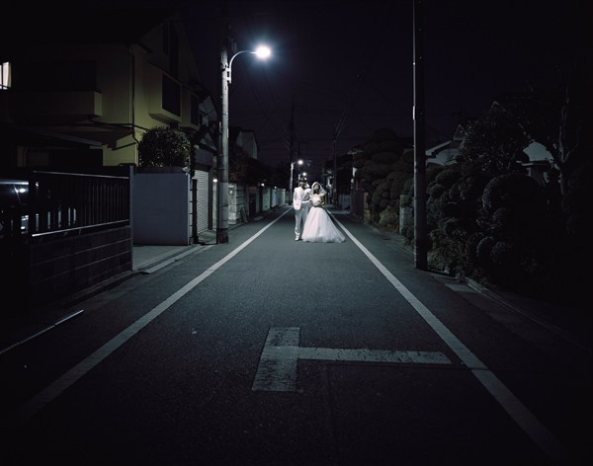

Communicating with thief

2010 Intervention project

Communicating with Thieves is a temporary, site-specific installation that imagines a relationship with a real thief. On aika varastaa! / It’s time to steal! (Finnish/English) slogans are projected onto the walls of several bank buildings. People seeing these signs can imagine any scale of bank robbery or theft from governing authorities and global capitalism, as an act of resistance in their imagination. This can be seen as resistance that speaks to the private-property system, since ‘wealth’ in all fields belongs to somebody from the low-income working class. The bank-robbery slogan symbolizes the fact that action is possible. But it cannot make people act. Nevertheless, thinking about money and the economy from the point of view of an outlaw bank-robber could trigger a change in the world.

The bear goes to the zoo to see bears

2010 Performance

”For my friends who cannot decide marriage with each othersyet, I hold a wedding at 2 am midnight under a streetlight”2009 Lambda print 1200 x 1500 mm
Dressing up my friends who cannot decide marriage each other yet as wedding party at midnight and shoot them on the street with only weak streetlight. As an idea of having relationship/intervention with friends community, that change what with it. We always take actions and think what we do within communities. This is my way of expression of love..

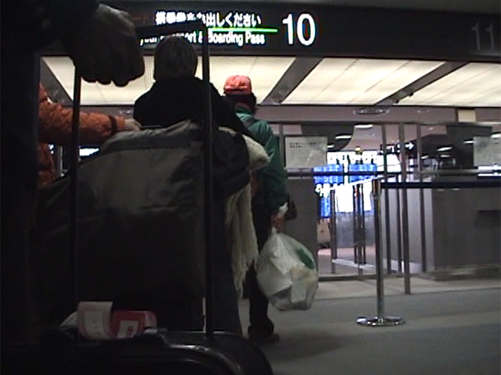
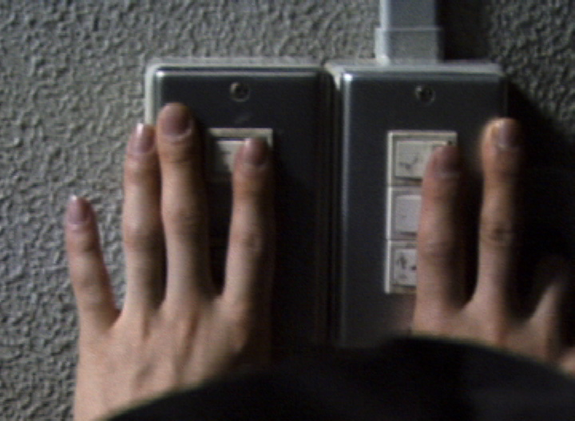

Go to San Francisco to throw away the garbage of my house 2006 Performance
Go to San Francisco to throw away the garbage of my house Tokyo to the dump of San Francisco, Also bring back the trash of San Francisco. This project is pretty simple. Trying to exchange garbage of each city Tokyo and San Francisco, Take a flight with collected garbage at my house in Tokyo, And bring back with garbage from San Francisco’s street. The aim of project is to recognize political similarly between Japan and US and to try to think about global environmental problem through the project.The garbage on the table is collected at the street in San Francisco.This is new piece made for “Listening : Living art from Japan and San Francisco” in 2006.

“Make Tama Art University PIKAPIKAPIKA”
2008 Performance
We will make all lights in Tama University of Arts blinked for about 30 minutes. 30 minutes of the repetition of lighting and turning off are to remain without fail in the memory. Moreover, this project was planned with a lot of art students help to re-concern our university. Also this project will realize only by the radical of the cooperation of a lot of students and parties concerned. 300 volunteer staff are recruited for this project implementation. We now call for volunteer staff of video and still camera crew.

Transporting puddle A to puddle B,
2004Performance
Transporting puddle water from East Belin to another puddle in West Berlin across the Berlin Wall had once existed.When asked whether i can how to relate to the Berlin Wall and Cold War as Japanese, and I have nothing to do with it, expect transporting puddle to another one. Toward the historical memory of the Berlin Wall and emerges through the act of minor rebellion can not cross the barrier.

